Advance Care Planning Day 2017 Campaign
- Introduction
To begin, Advance Care Planning is a process of reflection and communication. It is a time for you to reflect on your values and wishes, and to let your substitute decision maker know what kind of health and personal care you would want in the future if you were unable to speak for yourself. It is applicable to everyone, not just those who are sick and/or elderly.
Since 2012, April 16th has marked the day for National Advance Care Planning in Canada, serving as a reminder not only to start these important conversations with your substitute decision maker(s), but to review your wishes, if applicable. Each year, as part of Advance Care Planning (ACP) day, we choose unique campaign themes which guide the development of materials and resources for the ACP day toolkit.
This year, ACP Day landed on Easter Sunday, which posed a unique challenge for us as well as an opportunity to encourage families to take the extra time off of work to discuss their thoughts and wishes about future healthcare during the holiday.
- Overview of ACP Day 2017 Campaign
Without a doubt, this year’s ACP Day (April 16th) was a success. With the assistance of Channel 3 Communications, “Speak Up” developed resources for an ACP day campaign: “My Community.” These resources were translated and used by a variety of stakeholders across the country.
In addition, both print and radio media engaged with the Speak Up team to promote ACP Day coverage. A social media tool called “Thunderclap” was used this year as a way to deliver a unified message through Facebook, Twitter, and Tumblr on ACP day. Our goal of 100 pledges was exceeded by 157%. A survey was sent to the stakeholders following April 16th to gather information about the nationwide ACP Day events. The outcomes are listed below.
- Sales of resources
Many of our Stakeholders purchased Speak Up resources for their local use on and around April 16th. The results of these sales are seen below.
Resource | Quantity Sold January-April 2016
Wallet Card | 3,200
Carte de poche - Parlons-en | 200
Bookmark | 1,700
Signets sur la planification préalable des soins | 200
First Nations ACP Brochures | 300
First Nations ACP Posters | 100
National Workbook | 67
Manuel sur la planification | 28
Just Ask Conversation Card | 150
ACP Goals of Care Discussion Guide | 100
General ACP Poster | 150
How do I do ACP Poster | 400
Did you know? Poster | 260
Head in the sand Poster | 125
Cancer & ACP | 160
- Partners’/Stakeholders’ Activities

39 organizations across the county (and 1 in the United States) reported their ACP Day activities to us.

Organization | Type of Organization | Activity
Canadian Society of Palliative Care Physicians | National healthcare professional organization | Promoted ACP Day and the Speak Up campaign kit on their website, with social media, and through a media release.  CSPCP also joined an MOU with CHPCA, the College of Family Physicians of Canada and Pallium to promote ACP among their memberships.  ACP Day videos were well received at the Palliative Care Program committee meeting (April 7th).
Center for Studies in Aging and Health | Knowledge transfer & exchange center | Had an online portal for ACP and Healthcare Consent on website, including some information in FR as well. Website also has a FAQ and online ACP lessons (for healthcare professionals).
GlaxoSmithKline Corporation | Healthcare company | Distributed ACP Day information to their staff through the company’s intranet.
Fidelity Investments | Financial services provider | Fidelity distributed Speak Up resources to their employee intranet, and applied for Compassionate Care Company (CCC) designation.
Canadian Hospice Palliative Care Nurses Interest Group | Community based service organization | Developed a message which included copies of ACP materials and Thunderclap message, circulated twice to CHPCNG members via their listserv message board.  Also circulated information and promotional materials to CNA and nursing certification specialties colleagues (approx. 30).  Locally in NL, circulated to various organizations (e.g. Seniors resource Centre, Alzheimer's Society, Catholic Women's League, ALS society, Heart and Stroke, SW Association, Huntington's Society, etc.), including the Association of Registered Nurses of Newfoundland and Labrador (ARNNL), who posted on website.  Shared resources with government opposition leaders.  Also sent to Community Health Division Director of Eastern Health who indicated that she circulated it to all her regional leaders. Also shared with provincial lead, NL Prostate Cancer Support Group. Forwarded to NLPCA Board executive member who stated she would share with the palliative provincial committee.  ACP information also circulated to the Provincial Research Advisory Committee on rural issues in palliative care and the information.
Canadian Virtual Hospice | National Website (end-of-life care, loss & grief) | Social Media Engagement (Twitter, Facebook, LinkedIn, Google Plus). Also distributed ACP information through e-newsletter.
Canadian Cancer Society | National organization | Promoted ACP resources and videos on their social media accounts.
Canadian Breast Cancer Network | National organization | Promoted ACP Day in April edition of their monthly Outreach newsletter, distributed to 5000 people.
Pallium Canada | Education | Social media participation and distributed Speak Up materials.
Dying with Dignity | National not-for-profit | Participated in social media promotion of ACP Day.
National Initiative for the Care of the Elderly | Community based service organization | The End-of-Life Issues Theme Team partnered with the Law Commission of Ontario and the Toronto Central Palliative Care Network for an April 14th screening of Being Mortal as part of the organization's Reel Aging documentary series in connection with ACP Day.  The event was well received - and information packages (including the Speak Up! bookmark) distributed to all participants.
University of Colorado School of Medicine/ Denver Hospice | Medical education/ Hospice care and education | Integrated a Speak Up video into their certification program for training volunteers in facilitating and promoting ACP.
University of British Columbia Faculty of Medicine | Medical education | Published article Serious illness conversations and capturing advance care planning (Drs. Charlie Chen & Hayden Rubensohn) in the faculty’s Continuing Professional Development online journal This Changed My Practice. Offered 0.25 Mainpro+ or MOC Section 2* study credits for article. Article subsequently promoted online (e.g., resource page, social media) by College of Family Physicians of Canada, Health PEI, & Canadian Society of Palliative Care Physicians
Vancouver Coastal Health - Community Engagement Advisory Network | Patient and public education | Information Table/Poster display on April 10th in Vancouver General Hospital, main foyer with BC advance care planning guides and other information for the public and health care professionals.  International Association for Public Participation (IAP2) webinar about the CEAN Advance care planning initiative—acknowledged Advance Care Planning Day on April 16.  CEAN also advertised ACP Day in its newsletter and emails to CEAN members.
Interior Health, British Columbia | Regional health authority, LHIN, etc. | Connected with local legal estate planning organizations about how to integrate ACP into their counselling services.  Also supported local partners and community organizations to do some promotion.
BC Centre for Palliative Care | Regional health authority, LHIN, etc. | Supported the dissemination of the national Speak Up campaign materials, including encouraging groups to participate in the Thunderclap campaign and directed them to the Speak Up campaign kit.  To support hospice societies and other community organisations with their public ACP education and awareness activities, the centre also developed a media release, using the national “community” theme, for community organisations to publicise both their activities and ACP Day.  At least 8 community organizations hosted an ACP public education session with table displays and conversation game (http://commonpractice.com/hello) activities.  Promoted ACP Day to the South Asian community through the “Asian Star” newspaper, and through a radio interview about ACP with South Asian Radio in English and Punjabi on April 11th.  Promoted ACP Day to Hospice Palliative Care Volunteers through the BC HPCA newsletter.  Presented at the BC Cancer Agency Oncology Rounds on April 13th, presenting an adapted version of the ACP workshop presented at the BC Patient Safety and Quality Forum.
Fraser Health, British Columbia | Regional health authority, LHIN, etc. | Focused on internal engagement with staff and patients. Over 1000 resources were distributed in hospitals, Home Health, and community clinics. Ran a 6-week Green Sleeve campaign at hospital, targeting outpatients. Staff also received ACP materials and “Life and Death Matters” cookies.  April 8th: ACP public session delivered for the financial services community, titled “Planning for the Future.” Included workshops and panels with healthcare, legal, financial, and tax/estate advisors. Had 42 attendees.  April 13th: ACP Fair at Surrey Memorial Hospital for clinicians and the public. A hallway was set up to promote ACP “community” theme to public and healthcare professionals; included games, selfie stand, and whiteboard asking about what makes life meaningful.  April 18th: Another ACP Fair at Chilliwack General Hospital.  May 9th: Nurses Education Fair at Abbotsford Regional Hospital. Two ACP Booths for clinicians. Included games and prizes. About 250 people came through.
Alberta Health Services | Provincial health authority | Each of the AHS zones distributed ACP Day resources (Table 1). Also promoted ACP Day on AHS’ website (Figure 1).  April 18th: Representatives spoke about ACP/GOC during Question Period of the provincial legislature. They also hosted a booth in the rotunda, with posters, table tent cards, etc. An e-blast was sent to all MLAs about ACP Day events.  A local CBC program hosted by a physician talked about ACP throughout the week of ACP Day.  AHS Zones’ Activities:  Edmonton: ACP posters distributed widely and published an article in the EZ newsletter. An undergrad student in the U of A Faculty of Nursing ran two 1-hr workshops at the U of A campus the week before ACP Day, as part of her research project.  Covenant Health: ACP Day promotional package distributed to all sites encouraging them to host an ACP exhibit table. Also had a memo in their newsletter and an advertisement on their website home page.  Central: ACP/GCD flyer distributed to all staff and site administrators, circulated via Medical Affairs physician newsletter, and posted on bulletin boards and the Red Deer Regional Hospital. ACP/GCD flyer and ACP tent card distributed to all Central Zone Ethics Committee members and Alumni, for further circulation. ACP tent cards on tables in Red Deer Regional Hospital Cafeteria the week of April 10th.  Calgary  Eblast to all hospitals including rural, community homecare and Tom Baker Cancer Centre regarding ACP Day and location of information booths. Two hospitals (Rockyview, April 13th + Peter Lougheed, April 18-19th) hosted info booths with ACP promotions, including tips, resources, and messages around ACP. Also supplied special conversation cookies from Life and Death Matters. Also had public presentation at Grace Presbyterian Church, April 20th. Hosted an ACP Day booth at Mary O’Conner Conference on April 24th. Now planning to set up booths in 2 acute care sites and possibly a mall for higher public promotion.
Doing Deathcare Differently (AB) | Community based service organization | Hosted public presentations and individual small group kitchen table discussions about ACP.
Regina Qu’Appelle Health Region | Regional health authority, LHIN, etc. | Hosted a free public information session about advance care planning (May 10th), and promoted ACP resources on their website.
Concordia Hospital (ON) | Healthcare organization | Wrote articles about ACP in internal hospital newsletter.
Palliative Manitoba | Provincial hospice association | Promoted ACP information section on their website.
Ontario Medical Association | Provincial healthcare professional organization | Issued infographic on ACP and participated in social media engagement.
City of Lakes Family Health Team (ON) | Medical clinic | Working on implementing ACP with all patients over 65 years old during their annual physical.
Hospice Palliative Care Ontario | Provincial hospice association | Has adapted Speak Up ACP Day resources for Ontario and posted on Speak Up Ontario website. Also tapped into provincial Community of Practice to help get the word out about ACP Day.
Saint Vincent Hospital (ON) | Healthcare organization | Co-hosted an ACP information session in partnership with local Catholic church (approx. 25 people attended, 50% of whom had an ACP).  Facebook/Twitter accounts posted on ACP Day.  Introduced ACP to Home First patients and conducted ACP survey of outpatients.
Humber River Hospital (ON) | Healthcare organization | Promoted Speak Up’s CPR decision aids from our website, and is currently looking into incorporating them into integrated bedside terminals at the hospital.  Also provided an ACP education session to their patients.
Alert Best Nursing and Home Care (ON) | Community based service organization | Social media and website promotion of ACP Day.
Advance Care Planning Education Program | Patient education | The ACP education program, run by two hospices in Ontario (Hospice Waterloo & Hospice Wellington), developed an ACP quiz on their website, and promoted the Speak Up Ontario resources as well.  In addition, ran 4 ACP education and engagement sessions, and handed out ACP Day kits: (a) breakfast session for HR professionals which included a panel (a lawyer, physician, primary care lead, and two HR reps); (b) 2 sessions hosted by Independence Living Centres in KW and Wellington for persons with a physical disability; (c) a full-day session with long-term care champions to discuss integration of ACP policy/practice into their homes.
Providence Health (ON) | Healthcare organization | Engaged social media on ACP Day.
Grand River Hospital (ON) | Healthcare organization | Presented an ACP poster all week in hospital cafeteria.
VON Middlesex-Elgin (ON) | Healthcare organization | Hosted a Dialogues Event, similar to death café (May 9th), and delivered an ACP presentation to the local Parkinson’s group (March 14th).
Hamilton Health Sciences | Healthcare organization | On April 11th, HHS held a palliative care webinar with their leadership team and discussed ACP Day within that presentation. The team was assigned a challenge to start an ACP conversation with a family member during the long weekend. In collaboration with the Dr. Bob Kemp Hospice, HHS also organized an ACP workshop on April 19th for their community.
C.E. Dougherty Consulting | Community based service organization | Ran 7 community events around ACP and palliative care in Burlington, ON and area, including:  - Wellspring Well Talks on ACP (March 13th)  - North Yorkers for Disabled Persons (March 20th)  - A death café w/ ACP presentation (April 12th)  In all these events, audiences were directed to the resources on Speak Up Ontario website.
Hamilton Niagara Haldimand Brant LHIN | Regional health authority, LHIN, etc. | Promoted ACP website and resources on social media.
Nova Scotia Hospice Palliative Care Association | Provincial hospice association | Leveraged social media and local partners to promote ACP Day and scheduled 5 public presentations about ACP around ACP Day.
Health Prince Edward Island | Regional health authority, LHIN, etc. | An ACP brochure was planned to be sent to every island household with ACP information and instructions. Also had Health Minister Robert Henderson release the new PEI printed + interactive workbooks (from our CPAC project) and table it with a hard copy in the House.
Hospice PEI | Hospice | Had a large contingent of representatives present in the provincial legislature for a Ministerial Announcement. Placed notices in local media (The Buzz; Voice for Island Seniors) and promoted ACP resources in spring newsletter, circulated by mail and electronically.

Tables 1 & 2: AHS ACP Resource Distribution 2016/17
AHS Distribution Method | # of Items
Forced distribution | 5101
Requested materials | 58718
Total | 63819*

Most Distributed Resources | # of Items
ACP - Green Sleeve Package - For Community Physicians | 2013
ACP - GCD Green sleeve with Label | 48263
ACP - Goals of Care Guidebook - Conversations Matter | 4050
ACP - Goals of Care Designation - Order Form | 3009
ACP - Goals of Care Designation Tracking Record | 1894
ACP Goals of Care Designations - Planning Your Care Together - Poster Blue | 2180

Figure 1: AHS Website Screenshot
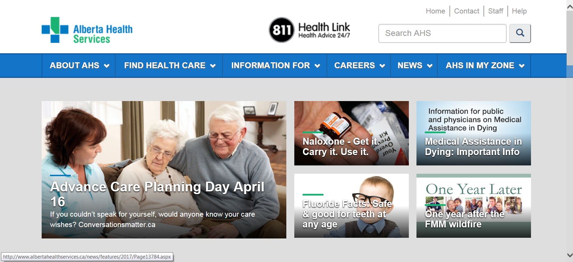

- Media

We identified 16 print and radio items about ACP Day across the country. Many of our Task Group members and ACP Champions gave interviews for the following coverage.
Print Source | Date Published | Title Article and Content
Coast Reporter | April 6 | Who will speak for you when you can’t?  Thinking and talking about your values, beliefs and wishes as they relate to health care, and what health-care treatments you would or would not want, will help you get the care that’s right for you when you need it – that’s what an Advance Care Plan can do for you.
Canadian Healthcare Technology Blog | April 19 | End-of-life planning now in MedChart  We live in a society where 8 out of 10 Canadians have never heard of Advanced Care Planning or creating Advanced Directives and 50% of us do not know our loved one’s advanced wishes. MedChart will begin to shift the tide on this important issue by providing resources for families and caregivers to engage in conversation about Advanced Directives through its partnership with BestEndings.
CBC Radio: The Current | April 11 | Why an ICU doctor says death ed is as essential as sex ed in high school  "I really think that like any other public health issue, this is something that for the health of our society every single person needs to be educated about," Dr. Jessica Zitter tells The Current's guest host Kelly Crowe. Bonnie Tompkins agrees. As the compassionate communities national lead for Pallium Canada — a group that aims to improve the quality of palliative care services through education — she says schools have a key role to play in normalizing the conversation around death, dying, loss and caregiving.
Langley Times | April 4 | Langley Hospice Society sets $1 million goal for new facility  The Society announcement said less than half of all Canadians have had conversations with their family and friends and even less have spoken with their doctor about what to do in case of an unexpected health crisis. Information about the Advance Care Planning process can be seen online at www.advancecareplanning.ca.
Guelph Talk Local | April 28 | Paul Tribe and guests discuss Advance Care Planning, substitute decision making and the health care system.  An interview about ACP with representatives from the Advance Care Planning Education Program.
CBC Radio: CBC News PEI | April 13 | Palliative Care consultant Dr. Mireille Lecours talks about advance care planning, and where Islanders can go for help.
Wawa-news.com | April 16 | Today is Advance Care Planning Day  The NE LHIN held a Death Café at this time last year to help begin conversations about death and normalizing the conversation about end-of-life. With Advance Care Planning Day on April 16, the NE LHIN encourages Northerners to focus on making end-of-life wishes known to loved ones while they are able to.
The Labradorian | April 8 | National Advance Care Planning Day on April 16  The Advance Care Planning in Canada’s Speak Up website (www.advancecareplanning.ca) has free, downloadable resources for advance care planning, including workbooks, videos, wallet cards and conversation starters, as well as resources and information about legal requirements for each province and territory.
Bay Today | April 15 | Northerners encouraged to plan for end-of-life  With Advance Care Planning Day on April 16, the NE LHIN wants Northerners to focus on making end-of-life wishes known to loved ones while they are able to.
McMaster Optimal Aging Portal | April 19 | What are your end-of-life wishes?  Contemplating the end of your life, and outlining the kind of health and personal care you wish to receive if you were unable to speak for yourself, is not always easy, but it’s important. Remember, it’s not just about you, it’s about ensuring that your family and friends have a clear plan to support your intentions.
BC Local News | April 4 | VIDEO: Workshop gets Langley people talking about their futures  Langley Hospice is one of the groups co-hosting this Planning for the Future workshop, along with Langley Seniors Resource Society, Langley Care Foundation, Langley Division of Family Practice, and Stepping Stone Community Services Society. April 16th is national advance care planning day, and this sessions aims to encourage people to get informed and start the conversation. More information is available via www.advancecareplanning.ca.
The Sudbury Star | April 15 | LHIN urges to plan end-of-life care  “Putting a plan in place ensures my family understands my values and wishes, and helps them with decisions that I may not be able to communicate in my final stages of life,” said Louise Paquette, CEO of the North East LHIN.
The Guardian | April 12 | Interactive online tool helps Islanders prepare end-of-life care  Health P.E.I. (in partnership with CHPCA) has created a new online planning workbook aimed at helping Islanders start conversations about their end-of-life care.
Comox Valley Record | April 13 | Sunday is National Advance Care Planning Day  Nursing students at North Island College helped get the conversations started this year for April 16, National Advance Care Planning Day, by hosting “Food For Thought” for their classmates and instructors.
Regina Leader Post | April 12 | An advance care plan speaks for you when you can't  “If you have a very serious health-care issue, what is important to you? What is quality of life for you?” said Marlene Glettler, senior health educator with advance care planning with the Regina Qu’Appelle Health Region (RQHR).
The Wellington Advertiser | April 14 | Learn about advance care planning  Waterloo Wellington’s Conversations Worth Having (CWH) is a local ACP project focused on raising awareness and equipping the general public, community professionals and health care providers with the correct information they need to start these conversations. For more information visit www.acpww.ca/news-events.

In addition, ACP in Canada distributed a news release for ACP Day, scheduled for release along the newswire on April 10th, 2017. The release was picked up by 40 media outlets with a potential audience of 21,510,358 people.

- Website Analytics
The success of this year’s ACP Day is also visible in the statistics of our website www.advancecareplanning.ca. The number of visits to the website increased in the months leading to ACP day (we launched our 2017 Campaign kit in January), and so did the number of new visits to the website. There is also a notable increase compared to last year’s stats.
 | Visits 2015 | Visits  2016 | Visits  2017 | New Visits  2015 | New Visits 2016 | New Visits 2017
January | 4,741 | 5,028 | 5,508 | 3,307 | 3,248 | 3,977
February | 5,532 | 8,507 | 5,545 | 3,782 | 5,168 | 3,822
March | 7,013 | 7,182 | 6,360 | 4,641 | 4,222 | 4,451
April | 8,987 | 9,804 | 6,961 | 6,266 | 6,715 | 4,977
Here is an overview of the ACP Day website statistics since 2013 to show the process of growth:
 | April 16th, 2014 | April 16th, 2015 | April 16th, 2016** | April 16th, 2017***
Visits* | 821 | 1,267 | 430 | 324
Pageviews | 2,532 | 4,053 | 949 | 768
New Visits | 605 | 979 | 354 | 272
Top Outside Referrals | 1. Appleby College Medical  2. University Health Network | 1. Facebook  2. Twitter | 1. Facebook  2. Twitter | 1. Facebook  2. Organic / Search Engine
*On an average day we have between 100 and 200 visits to our website.
**In 2016, April 16th was on a Saturday.
***This year in 2017, April 16th was on Easter Sunday.
Our campaign kit webpage received a lot of traffic from January-April 2017 with over 2,964 page views.

- ACP in Canada: ACP Day Promotion in What’s New Section

As a way to help normalize the conversations on advance care planning, a series of articles and stories were featured on the Advance Care Planning website. The following were posted on the What’s New section of our website:
- ACP and the elderly: Educational programs that facilitate critical conversations (Dr. John Puxty, ON)
- Conversations help create a community of care (Lin and John Palin, BC)
- Amy Tan talks about her harrowing care accident, the decisions her family had to make, and why everyone needs to make advance care planning a priority (Dr. Amy Tan, AB)
- Looks Who’s Talking (various)

- Twitter Analytics
We had very a successful ACP day on April 16th. The hashtag (#ACPDay2017) was picked up very quickly this year with organizations and groups, such as the Brain Tumour Foundation of Canada, College of Family Physicians Canada, Ontario Medical Association, Canadian Virtual Hospice, Canadian Partnership Against Cancer, The Canadian Cancer Society and each of the provinces and territories accounts, Canadian Cancer Action Network, Canadian Nurses Association, and Heart and Stroke. The following are the social network metrics for ACP Day.
Followers:
- As of March 10th, we had 2,685 followers on Twitter
- As of May 11th, we increased to 2,825 followers.
April 16, 2017 (Sunday):
- 9 tweets from ACP account on ACP Day
- 27 re-tweets of our ACP Day tweets
- Organic Impressions: 2,644 (number of times users saw our tweets on Twitter)
- Link Clicks: 30 (number of times users clicked on URLs)
April 2017:
In April, there was a surge in organic impressions (the number of times a user saw our tweets on Twitter) and engagements (the number of times a user interacted with a tweet – clicks, retweets, replies, follows, likes, links, etc.). [See Twitter Activity Overview]

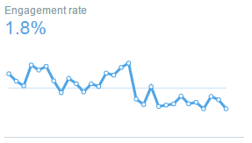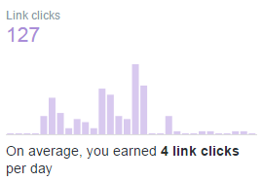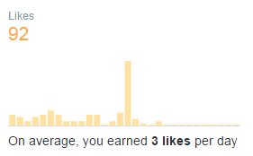

- Facebook Analytics (March 16 – May 1)
- As of March 10th, we had 803 fan likes.
- As of May 1st, we had an increase in fan growth to 839 likes.
- Page Impressions: 31,670 by 20,238 users (total number of times any Facebook user (fan or non-fan) saw any content associated with our Page)

Facebook Boosted Posts
The first boosted post on Facebook had a budget of $30 and ran for 3 days, with a targeted audience of men and women ages 25 – 65+ who live in Canada, The ad reached 1,737 users and had 58 engagements.
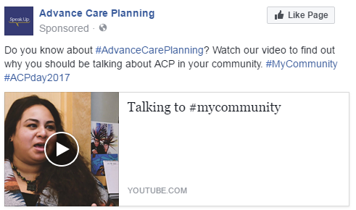

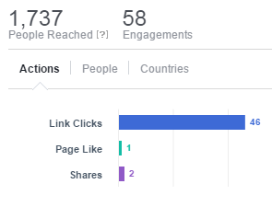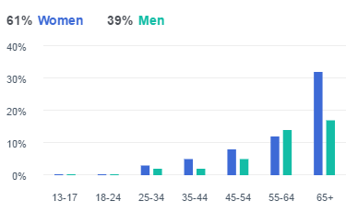

The Second boosted post on Facebook had a budget of $100 and ran for 12 days, with a targeted audience of men and women ages 25 – 65+ who live in Canada. The ad reached 4,655 users and had 106 engagements including being shared 22 times.
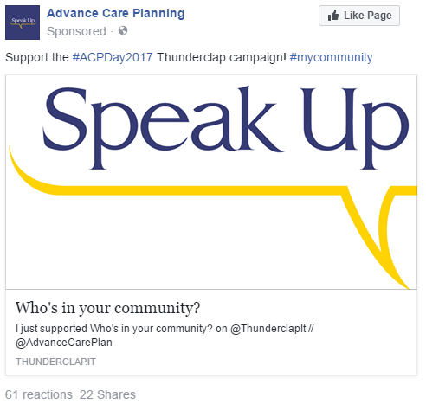
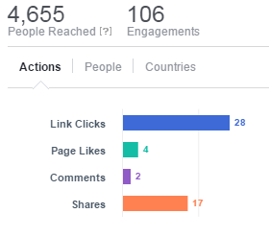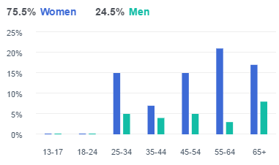
- Thunderclap

On April 16, a unified message from all of our supporters was broadcasted simultaneously on social media and made a big impact. It helped us get heard across the country by saying something together.
Statistics for our Thunderclap:
Unique Supporters 157 of 100
Total Percentage Complete 157% of Goal
Total Social Reach 409,486 people
Total Facebook Supporters 110
Total Twitter Supporters 78
Total Tumblr Supporters 1

